CIS 4004 – Exam #1 – Spring 2011

February 23, 2011

105 points total

Name:

(Please print clearly)
KEY

Multiple Choice/True-False Section (3 points each) – Circle the correct answer.

- Would an XHTML document pass Strict-DTD validation if it included the following line of markup?
<p><b>A picture<img src=”picture.jpg” alt=”pic” /></p></b>
  - Yes
  - No

- Working from the center of the box toward the outside, a CSS box consists of:
  - content, margin, padding, border
  - content, border, padding, margin
  - content, padding, margin, border
  - None of the above are correct

- The visible width of an element on a Web page is the total of the content width, padding width and border width.
  - True
  - False

- An element that is positioned using the float property is rendered in normal flow and then shifted either left or right as far as possible within its container (element).
  - True
  - False

- Using CSS-P an element can be placed on a page using one of four different techniques. If you want the elements to appear in the order in which they appear in the XHTML document you would be using
  - relative positioning
  - absolute positioning
  - float property
  - normal flow

- The clear property is used whenever you want an element to “clear” another element which is absolutely positioned.
  - True
  - False

- Absolute positioning is used to place an element in a fixed position on the web page. This is done by setting the position property to absolute. Which of the following additional properties must also be specified for an absolutely positioned element?
  - top
  - left
  - right
  - bottom
  - any of (a), (b), (c), or (d)
  - any of (a). (b), or (d)
  - only (b) or (c)
  - all of (a), (b), (c), and (d)

- To be semantically correct, a navigation list should be constructed using <p> elements set to display either as a block or inline.
  - True
  - False

- Given the storyboard shown below, which of the elements has the highest z-index value?
  - element A
element A
element B
element C
  - element B
  - element C
  - they are all the same

- Suppose an XHTML document is styled with both an external and an internal style page. Further suppose that both the external and internal style page contain definitions for the <p> element. When the page is rendered by a browser, any <p> element will have the style defined in the:
  - external style sheet
  - internal style sheet.
  - both styles apply
  - can’t really tell from the information provided

- You can float an element either to the left or right. You can also float an element to the top or bottom.
  - True
  - False

- An element that is configured with the property display: block will be rendered as a block element even if it is an inline element. For example:
<a style=”display: block”> ….</a> would display the anchor (link) as a block element and not an inline element.
  - True
  - False

- In CSS, which has higher precedence, an id selector or the universal selector?
  - id selector
  - universal selector

- Which of the following is NOT a valid XHTML tag?
  - <strong>
  - <em>
  - <hr />
  - <bold>
  - <code>

- In making XHTML-based forms, both the checkbox control and the radio button control are created using the <input /> tag.
  - True
  - False

- Which one of the following represents valid XHTML code for a submit button?
[1] <input type=”button” value=”submit” name=”Submit Me” />
[2] <input type=”submit” value=”Submit Me” />
[3] <select type=”submit” value=”submit”>Submit Me</select>
[4] <input method=”submit” value=”Submit Me” />
[5] <select method=”submit” value=”submit”>Submit Me</select>
- In XHTML, every tag and attribute name must be all lowercase.
  - True
  - False

- In CSS, a user-specified image can be used as a list item bullet for an unordered list. Such a bullet is specified with the list-style-image property.
  - True
  - False

- The total horizontal width of an element on a Web page is the total width of the content, padding, border, and the left margin.
  - True
  - False

- Which of the following lines of code will attach a file called main.css as the CSS rule set for an XHTML document?
[1] <link rel=”text/css” type=”stylesheet” href=”main.css” />
[2] <link rel=”stylesheet” type=”text/css” href=”main.css” />
[3] <link rel=”text/css” type=”stylesheet” src=”main.css” />
[4] <link rel=”stylesheet” type=”text/css” src=”main.css” />
[5] <a href=”main.css” type=”text/css” rel=”stylesheet” />
- What should the CSS selectors be defined as to make the following XHTML code segment display as it is stated in the example below?
<span class=”warm”>This text should be BLUE!</span><br />
<h4 class=”warm”>This text should be RED!</h4><br />
<h4>This text should be BLACK!</h4>
  - #warm { color: blue; } h4.warm { color: red; } h4 { color: black; }
  - warm { color: blue; } h4:warm { color: red; } h4 { color: black; }
  - .warm { color: blue; } h4:warm { color: red; } h4 { color: black; }
  - .warm { color: blue; } h4.warm { color: red; } h4 { color: black; }
  - warm { color: blue; } h4.warm { color: red; } h4 { color: black; }

- What are the attribute(s) of an <img /> tag that are required for XHTML 1.0 Strict validation?
  - src and alt
  - href and type
  - width and height
  - alt, href, and height
  - height

- Which of the following is NOT a valid cascading style sheet (CSS) style rule?
  - p.active { font-variant: normal; }
  - h2, h1 { font-size: 24pt; font-family: Courier, Prestige; font-style: italic; }
  - large_title { background-color: #C8C80C; text-size: 24pt; }
  - #space13 { font-family: Arial, Helvetica, Futura, sans-serif; font-weight: bolder; }
  - * { color: rgb(200, 200, 12); }

- What are the three (3) different levels of cascading style sheets (CSS)?
  - Static, Dynamic and Defined
  - Primary, Secondary and Tertiary
  - Public, Private and Protected
  - External, Embedded (global) and Inline
  - Local, External and Global

- In an XHTML document (web page), what is the intended purpose for the alt attribute of the <img /> tag?
  - To specify the text to be displayed when it is not possible to display the image
  - As a mouse-over text to be displayed when the cursor is over the image
  - To specify the alternate text-based name for the image
  - Answers (a) and (b) are both correct
  - Answers (b) and (c) are both correct

- Which of the following is NOT a valid CSS property for positioning and formatting text in an XHTML document (web page)?
  - text-indent
  - text-align
  - text-direction
  - letter-spacing

- A CSS rule consists of how many parts?
  - 1
  - 2
  - 3
  - an arbitrary number
Short Answer Section (points as shown)
- (19 points) Create the CSS (external style sheet) and re-write the XHTML markup shown below so that when rendered it will look like the screen shot shown on the screen in front of you (and also on the next page). Assume that each box is 100 pixels x 100 pixels with no border and no padding. Each box has 5 pixels of margin on all sides. DO NOT change the order of the <div> elements in the markup to achieve your results. DO NOT use absolute positioning. The box positioning must be done strictly with CSS. Use an external stylesheet.

<head>
<title>Exam 1 - Question 28 </title>
</head>
<body>
<div id="box3">Box 3 is yellow</div>
<div id="box2">Box 2 is red</div>
<div id="box1">Box 1 is blue</div>
</body>
</html>

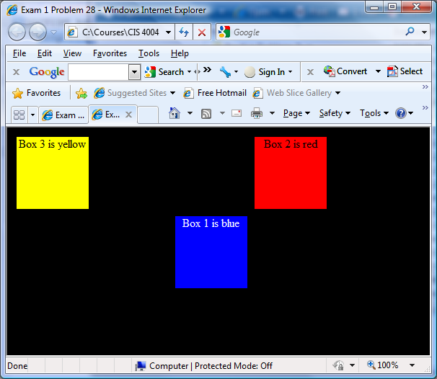

A box has a width & height of 100 pixels each and a margin of 5 pixels on each side. Thus, the total space occupied by each box is 110 pixels in height and 110 pixels in width.

To move box2 to the right side of box1 using relative positioning requires that box2 be positioned 220 pixels left of where it would default using relative positioning.

